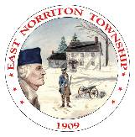
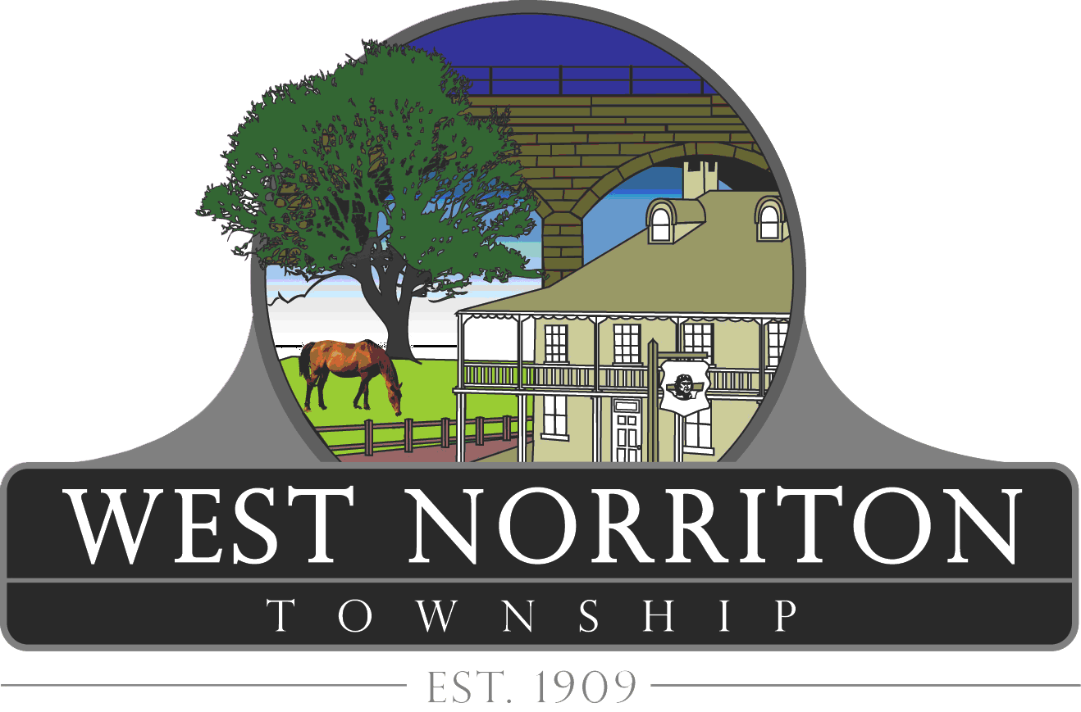
NORRITON DOG PARK
RULES & REGULATIONS

To ensure safety and enjoyment for all, park users must strictly observe the following rules and regulations. Those found in violation will lose Dog Park privileges without refund and may be subject to fines.
1. Norriton Dog Park is open from dawn to dusk. The Dog Park may be closed due to inclement weather and scheduled maintenance. When possible, advanced notice of Dog Park closure will be posted.
2. The Dog Park is for dogs, their handlers, and those accompanying them. No other use is permitted. All users must be registered members with West Norriton Township Parks and Recreation to utilize the Dog Park.
3. All dogs must be healthy and must wear a collar displaying their current member tag, rabies tag and dog license as required by PA law. Dogs with contagious health conditions are not permitted at the park.
4. Use of the Dog Park is at your own risk. Each owner is solely responsible for their and their dog's actions and assumes all liability for injury or damage suffered to any person, dog or property.
5. Dogs younger than 4 months of age, unneutered male dogs and unspayed female dogs, are not permitted in the Dog Park.
6. Members must accompany and monitor dogs closely. Dogs must always be in view of and under voice command of their handlers. Members must refrain from being distracted on their cell phones.
7. No smoking, alcohol, food, or glass containers are permitted in the Dog Park.
8. Children under the age of 14 are not permitted inside the Dog Park. Children aged 14-17 must be accompanied by an adult.
9. Dogs must be leashed and under owner’s control outside of the Dog Park, as well as when entering and exiting the Dog Park. Members must keep the leash in their possession at all times.
10. Under no circumstances should a dog be tethered by the leash to any object in the park.
11. No more than two dogs per member are permitted at one time. If two dogs are in different weight groups, then one member must accompany each dog.
12. Members are required to clean up after their dog(s). All waste must be bagged and disposed of properly in marked receptacles.
13. Leaving the gates open, tied back or unlatched is prohibited.
14. Members must leash their dog(s) and exit the Dog Park if their dog(s) is/are acting aggressively or fearfully.
15. Prong, pinch, choke or spike collars are not permitted.
16. The park may not be utilized for any private use or gain without the written approval of the West Norriton Township Parks & Recreation Department.
17. For all emergencies, call 911. For non-emergencies, call 610-630-1251. Report serious dog bites to the police.

